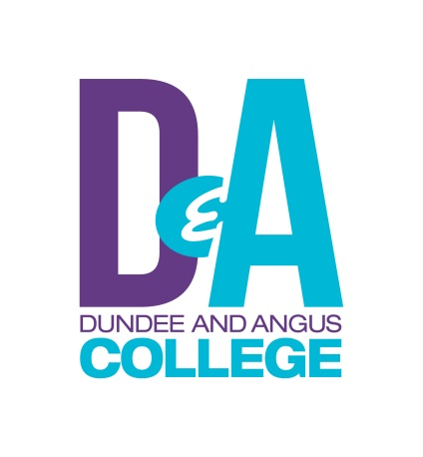
Cambridge Certificate in English Language Teaching to Adults (CELTA) 2024-25

CELTA is an internationally recognised initial teaching qualification in Teaching English as a Foreign Language (TEFL) and teaching English for Speakers of Other Languages (ESOL). It is the basic requirement for those embarking on a career in English Language teaching to ESOL learners both abroad and in the UK.

The CELTA course is a practical, classroom-based course giving a good foundation in basic teaching techniques – classroom management, lesson planning, error correction, language analysis and using resources, to name but a few. Input sessions, which are led by the trainers, focus on teaching methodology and language awareness. This input is put to practical use in the preparation of lesson plans and teaching practice.

There is a required minimum of 120 contact hours (on our course you receive over 130 hours), more than half of which are devoted to preparation and planning for teaching and post teaching practice reflection. There are 6 hours of assessed face to face teaching practice and 6 hours spent observing qualified teachers (at least 3 hours of which are live observation). The course includes a minimum of 120 additional learning hours of independent background reading, assignment writing and lesson preparation. There are 4 written assignments (of 3,000 words in total), which are internally assessed and externally moderated.

Learners will be given the opportunity to observe experienced teachers and to gain valuable skills by working as volunteers in our ESOL classes.

Part-time Study

Our course is part-time. It starts on Thursday October 24th 2024 and runs for between 15-18 weeks (this depends on the number of participants in each Teaching Practice group), finishing on Thursday 13th March 2024 if the course is full. Attendance is required twice a week, on Tuesdays for input from 5.30pm–8.45pm and on Thursdays for on campus input, teaching practice, feedback and lesson preparation from 9am-4.30pm. There may be 2-4 hours (over the whole course) outside these times when participants need to be free for class observation.

There will be a maximum of 10 places available on the course.

Applications for the courses can be submitted at any time. However, due to the popularity of the course, places fill up very quickly so early submission of your application is advisable.

The Cost
The course costs £1,200 (this may be subject to change). This includes the Cambridge assessment fee. If an applicant is offered a place, an acceptance letter and Learning Agreement are issued – the Learning Agreement must be signed and returned with the £100 deposit within 7 days of receipt. The outstanding balance must be paid at least 2 weeks before the course start date. If your fee will be paid by your employer or an external body, you are required to declare this at interview.

You may be eligible to get an Individual Training Account (ITA) account to contribute towards the cost of the course. More information can be found on: https://www.myworldofwork.co.uk/

If there are fewer than 8 participants, the course may be postponed or cancelled. If it is cancelled, the fee will be refunded in full.

Entry Requirements
Applicants should normally be at least 20 years old (although we may accept candidates aged between 18 and 20) and have a standard of education which would allow entry to higher education. If English is not your first language, you must have a very high level of spoken and written accuracy. (Minimum CPE or a recent IELTS score of 8.0 overall, including 8.0 for written English). You should also have basic ICT skills and access to a device and the internet. You will need to demonstrate a certain level of language awareness and the potential to develop the necessary skills to become effective teachers and complete assessments.

Entry Procedures include:
- a pre-interview task requested after submission of application form
- an interview involving group discussion, a written task, teaching a mini lesson and a one-to-one interview

The interviews are normally held in small groups and will last for a couple of hours. They are designed both to assess candidates’ language awareness and their potential to develop the necessary skills to become effective teachers. They also give a flavour of what to expect on the course. These interviews may be held on Microsoft Teams or at Gardyne Campus.

Contact
For more information please contact Lia Moss:

email: l.moss@dundeeandangus.ac.uk
telephone: +44 (0)1382 834902
fax: +44 (0)1382 448866
web: https://dundeeandangus.ac.uk/subject-areas/english-language-tefl-british-sign-language/

