EXAMPLE SESSION PLAN
NAME | John Smith | DATE | 15th March 2021 | SPORT | Football
 | DESCRIPTION of ACTIVITY | DIAGRAM of ACTIVITY |  | TIME | KEY POINTS | EQUIPMENT
WARM UP | - Jogging with ball  - Various commands – different directions and different parts of feet  - Dynamic Stretching – Lower Body Focus – Leg Swing Forward, side and back; hip mobility exercises | 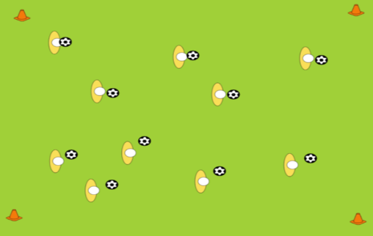 |  | 5 mins | - Warm Body up gradually  - Increase tempo as warm up progresses  - Lots of touches of ball in warm up | 10 x size 5 Footballs  4 Orange Cones
DRILL/PRACTICE 1 | Passing Drill 1  - Players will Pass and Move around outside of square  - A1 to B; B to C; C to D; D to A2 |  |  | 5 mins | - Correct weight of pass  - Follow ball once played  - Pass on outside of square  - Angle off cone to receive  - 1st touch sets up the pass | 8 Orange Cones  8 x Size 5 Footballs
DRILL/PRACTICE 2 | Passing Drill 2  - 3 v 1 Possession Rondo  - Player in middle works for 30 seconds and is trying to win ball or force a mistake  - Players on outside are trying to keep ball away from player in middle  - Change player after 30 seconds | 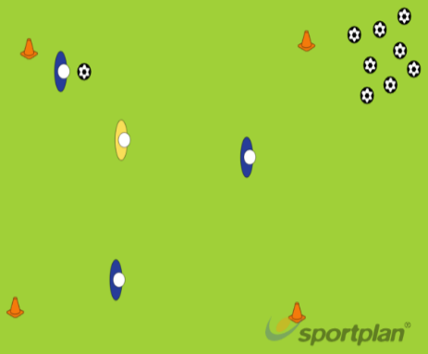 |  | 5 mins | - Identify best space to move to and best option to pass  - Provide an option for the passes  - Passes must be made quickly | 8 Orange Cones  20 x Size 5 Footballs  Stopwatch  3 x Yellow Bibs
CONDITIONED GAME/ACTIVITY | Passing Game  - 4 v 4 game – with 2 side players  - Can’t pass ball backwards – encourages forward passes and movements  - Side players can be used as extra players on each team – they have 1 touch | 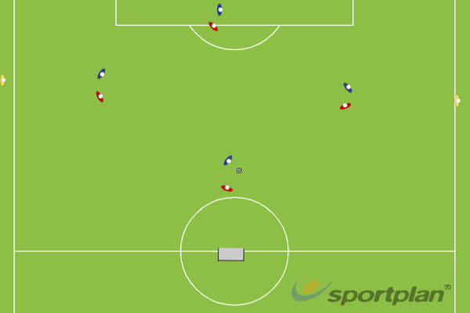 |  | 10 mins | - Normal game  - Condition forces players to try to pass and move forward – encouraging attacking play  - Attacking and defensive principles apply | 2 x 7 a side goals  4 Red Bibs  4 Blue Bibs  2 Yellow Bibs  6 x Size 5 Footballs
COOL DOWN | Gentle Movement around the pitch  Slowing down to a walk  Static Stretches |  |  | 5 mins | Return body and mind to natural state – reduce breathing and pulse  Stretches to start recovery | N/A

